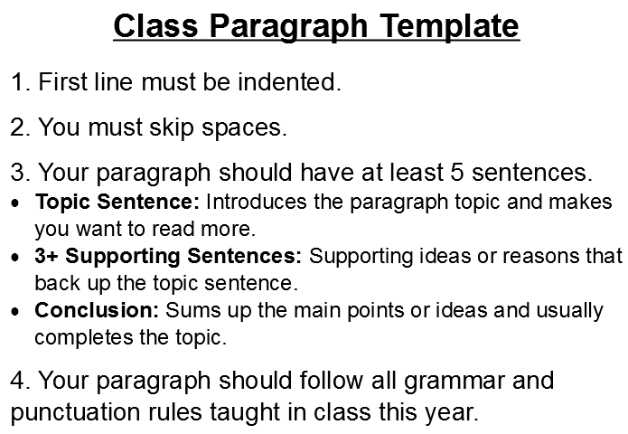
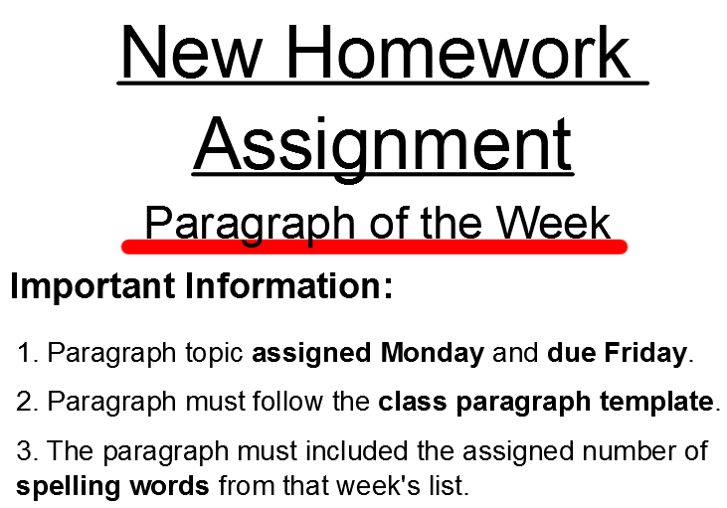
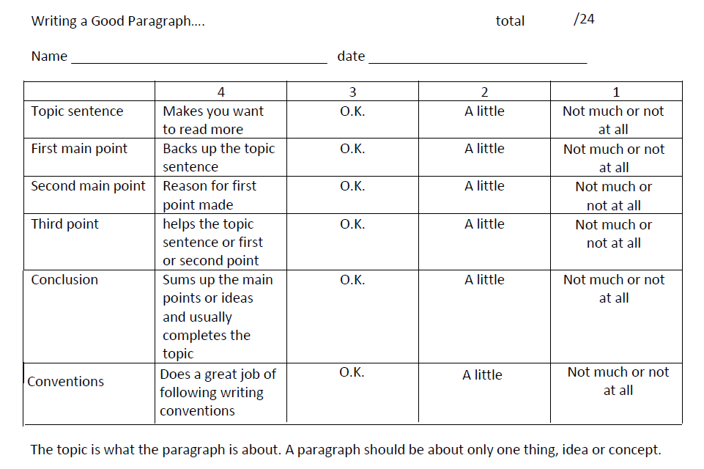
Marking Rubric

If there are any questions about this new homework assignment please feel free to email Mr. Tuck at chris.tuck@lethsd.ab.ca.

